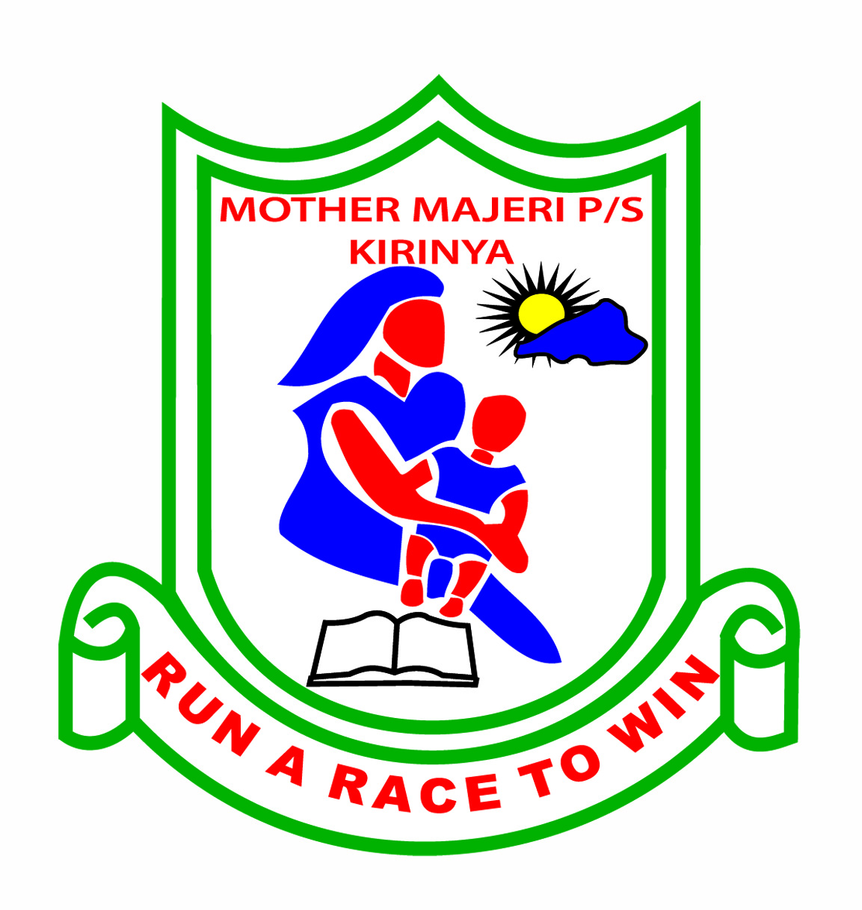MOTHER MAJERI NURSERY SCHOOL

**END OF TERM II EXAMINATION, 2024**

**CLASS : MIDDLE CLASS**

**AGE : 4-5 years**

# SUBJECT : DRAWING AND SHADING

My name is :_______________________________________

**1. Shade well.**

blue green

red

yellow

**2. Draw these people at home.**

|  |  |  |  |
| --- | --- | --- | --- |
|  |  |  |  |
| mother | sister | father | baby |

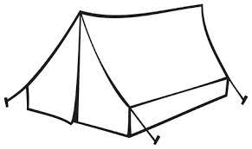 **3. Shade these houses.**

tent

hut

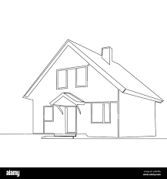 bungalow

**END**